 | Epsom & Ewell F.C.  12  v  Hanworth Villa F.C.  Saturday, 7th November 2015
Good afternoon! We welcome the players, supporters and officials of Hanworth Villa, together with today’s officials and our own regular faces. We also say hello again to Dale Marvell, although we hope that he doesn’t have a good game today!

Last season we required a late Kyle Hough equaliser to rescue a point in a 1-1 draw here although the trip to Hanworth in early September contained much happier memories as we won 5-2 in Middlesex, with Sam Robinson scoring a hat trick that day.

Our last appearance at High Road resulted in a late, single goal victory over Chessington & Hook United although I felt we were good value for the points, even if the players and supporters had to wait until the 89th minute to celebrate Tom Neale’s header from Matt Tanton’s superb cross.

We then travelled to Knaphill, where we played well but had to settle for a draw. Daryl Cooper-Smith had given us the lead in very similar circumstances to Kyle Hough’s goal at Ashford in that he won a challenge with the keeper with the ball squirting towards and eventually into the net. Unfortunately, just like Kyle at Ashford, Daryl injured himself in the challenge and had to go off!

We still looked well in charge but midway through the second half we were pushed back a bit more and we were made to pay for chances missed when the home side equalised after 74 minutes.

Following that match, we faced the title favourites Hartley Wintney on their own patch, and gave them a big fright, becoming the first club to take a point from Green Lane this season in a 3-3 draw. Only Step Two Eastbourne Borough have scored three against them this season, so it was a great performance, especially after we had trailed 3-1 after an hour in blustery conditions that made constructive football difficult. A truly heroic performance.

Following today’s match we travel to Bedfont Sports on Tuesday and to Colliers Wood next Saturday for two more important League fixtures before returning here on Saturday 5th December for a home match with Guildford City. Nether are far away, so why not come and support us?

Our match sponsor today is Maggie Beddoe who has kindly donated some of her £297 Salts Super Six winnings. We are back to £50 today for the jackpot but it will rise shortly, I’m sure, so keep buying the tickets!

I know I keep repeating this, but we are in desperate need of further sponsorship; both for the matches and for players. Please help your club, as every donation helps!

Finally, please note that we will be holding a minute’s silence before the game in respect of those who tragically lost their lives in the recent attacks in Paris.

Enjoy the game!

Rich

You can now follow us on Facebook www.facebook.com/epsomandewellfc or Twitter @EEFCOfficial

Cover Photos by Gemma Jarman

- Daryl Cooper-Smith challenges the keeper to score our goal at Knaphill
- Daryl just making sure it was in!


Cherry Red Records Combined Counties League
Premier Division Table 2015/16
inc Tuesday 17th November | P | W | D | L | F | A | Pts | GD | H | A
Hartley Wintney | 15 | 13 | 2 | 0 | 53 | 14 | 41 | +39 | 30/1 | 3-3
Ashford Town (Mx) | 16 | 12 | 0 | 4 | 37 | 20 | 36 | +17 | 30/4 | 3-2
Camberley Town | 15 | 10 | 3 | 2 | 26 | 12 | 33 | +14 | 16/4 | 20/2
Epsom & Ewell | 15 | 9 | 5 | 1 | 34 | 15 | 32 | +19 | X | X
Horley Town | 14 | 8 | 2 | 4 | 34 | 18 | 26 | +16 | 27/2 | 28/12
Hanworth Villa | 14 | 8 | 1 | 5 | 25 | 21 | 25 | +4 | 21/11 | 23/4
Spelthorne Sports | 17 | 7 | 3 | 7 | 31 | 34 | 24 | -3 | 16/1 | 6-2
Chessington & Hook | 16 | 7 | 2 | 7 | 29 | 32 | 23 | -3 | 1-0 | 19/3
Guildford City | 17 | 7 | 2 | 8 | 36 | 40 | 23 | -4 | 5/12 | 2/4
Colliers Wood United | 19 | 7 | 1 | 11 | 41 | 35 | 22 | +6 | 3-1 | 28/11
Windsor | 15 | 5 | 7 | 3 | 26 | 28 | 22 | -2 | 2-2 | 23/1
Raynes Park Vale | 16 | 7 | 0 | 9 | 35 | 34 | 21 | +1 | 3-1 | 28/3
Knaphill | 14 | 6 | 2 | 6 | 23 | 16 | 20 | +7 | 12/3 | 1-1
Farnham Town | 15 | 6 | 2 | 7 | 26 | 23 | 20 | +3 | 1-0 | 6/2
AFC Hayes | 17 | 6 | 2 | 9 | 25 | 30 | 20 | -5 | 1-1 | 9/1
Westfield | 14 | 5 | 4 | 5 | 18 | 22 | 19 | -4 | 26/3 | 0-0
Sutton Common Rovers | 15 | 5 | 2 | 8 | 24 | 32 | 17 | -8 | 19/12 | 2-1
Bedfont Sports | 14 | 3 | 6 | 5 | 19 | 19 | 15 | 0 | 13/2 | 24/11
Chertsey Town | 16 | 3 | 5 | 8 | 13 | 24 | 14 | -11 | 0-1 | 5/3
Badshot Lea | 15 | 4 | 1 | 10 | 19 | 42 | 13 | -23 | 9/4 | 12/12
Redhill | 15 | 3 | 2 | 10 | 23 | 35 | 11 | -12 | 2/1 | 1-0
Cove | 14 | 1 | 0 | 13 | 7 | 58 | 3 | -51 | 8/12 | 7-0

Lucky Day? – 21st November
Played 14 - W 5 D 3 L 6 - F 24 A 24 - PPG 1.29 - Below Average
Our Club record against Hanworth Villa
Played 12 - W 5 D 3 L 4 - F 26 A 22 - PPG 1.50 - Average
Largest wins and losses
6th September 2014 - W 5-2 - League - 26th April 2014 - L 1-4 - League
Last visit
Tuesday 3rd March 2015 - D 1-1 - Combined Counties League

Club Manager - Glyn Mandeville
Good afternoon everyone and welcome to today’s match.

We come into today's game after two draws against Knaphill and Hartley Wintney, where some very poor time keeping and very bad decisions by the referees stopped us from getting all six points.

I hope the weather is better for us all today as this last week has been very wet.

I would like to welcome Mr Marvell and his new team mates for today's game and wish them and their supporters a safe trip home.
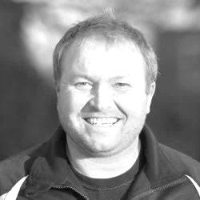
I hope you enjoy today’s game. Thank you for your support.

Manders

Club Captain - Sam Currie

Good afternoon and welcome to today's game against Hanworth Villa.

We come into the game off the back of two draws; one good draw in hindsight considering we came back from 3-1 away from against league leaders Hartley Wintney, and one draw away at Knaphill where a sloppy ten minute period and a lack of clinical finishing meant we missed out on what should have been the full three points.

In both games we certainly feel we had the chances to win these games.

Today’s game will be another tester and with the inclusion to their squad of Dale Marvell who until recently was with us, know that it will be a tough game as they sit in the top half of the table and are usually well organised. However, we know three points is required to keep up the challenge at the top.

The boys know with the right commitment, attitude and composure (as shown on Tuesday night) we are more than capable of challenging at this end of the table.

We hope Hanworth’s players, staff and supporters enjoy their afternoon and have a safe journey home following the game.

All the best and thank you for your continued support as always.

Sam

Quick Statistic!
On Tuesday at Hartley Wintney we conceded the 5,000th goal in our club history when Craig Hastings unfortunately knocked the ball past Michael Eacott. Unlucky Craig!

It’s not all bad though as we’ve scored 5,158 times!

Latest Results and Fixtures
Combined Counties League – Saturday 7th November
Bedfont Sports | 2-1 | Guildford City
Chertsey Town | 0-0 | Sutton Common Rovers
Colliers Wood United | 5-1 | AFC Hayes
Epsom & Ewell | 1-0 | Chessington & Hook United
Hanworth Villa | 1-3 | Hartley Wintney
Surrey Senior Cup Second Round – Tuesday 10th November
Godalming Town | 1-0 | Guildford City
Molesey | 2-1 | Raynes Park Vale
Combined Counties League – Tuesday 10th November
Bedfont Sports | 1-1 | Hartley Wintney
Redhill | 0-1 | Farnham Town
Windsor | 5-1 | Cove
Combined Counties League – Saturday 14th November
AFC Hayes | 2-2 | Chertsey Town
Ashford Town (Mx) | 4-1 | Redhill
Camberley Town | 5-0 | Farnham Town
Hartley Wintney | 4-0 | Westfield
Knaphill | 1-1 | Epsom & Ewell
Spelthorne Sports | 2-1 | Colliers Wood United
Sutton Common Rovers | 1-0 | Badshot Lea
Windsor | 1-1 | Guildford City
Combined Counties League – Tuesday 17th November
Hartley Wintney | 3-3 | Epsom & Ewell
Surrey Senior Cup Second Round – Thursday 19th November
Horley Town | V | Badshot Lea
F.A. Vase Second Round – Friday 20th November
Sutton Common Rovers | V | Beckenham Town
F.A. Vase Second Round – Saturday 21st November
Colliers Wood United | V | Loxwood
Hartley Wintney | V | Windsor
Knaphill | V | Tunbridge Wells
Newhaven | V | Camberley Town
Combined Counties League – Saturday 21st November
Badshot Lea | V | Guildford City
Chertsey Town | V | Cove
Epsom & Ewell | V | Hanworth Villa
Farnham Town | V | Ashford Town (Mx)
Horley Town | V | Bedfont Sports
Latest Results and Fixtures
Combined Counties League – Saturday 21st November
Raynes Park Vale | V | Spelthorne Sports
Westfield | V | Chessington & Hook United
Combined Counties League – Monday 23rd November
Sutton Common Rovers | V | Knaphill
Combined Counties League – Tuesday 24th November
AFC Hayes | V | Westfield
Bedfont Sports | V | Epsom & Ewell
Camberley Town | V | Spelthorne Sports
Hanworth Villa | V | Colliers Wood United
Hartley Wintney | V | Badshot Lea
Raynes Park Vale | V | Windsor
Redhill | V | Guildford City
Combined Counties League – Saturday 28th November
AFC Hayes | V | Farnham Town
Badshot Lea | V | Hanworth Villa
Colliers Wood United | V | Epsom & Ewell
Cove | V | Horley Town
Guildford City | V | Camberley Town
Knaphill | V | Bedfont Sports
Raynes Park Vale | V | Chertsey Town
Redhill | V | Hartley Wintney
Spelthorne Sports | V | Ashford Town (Mx)
Westfield | V | Sutton Common Rovers
Windsor | V | Chessington & Hook United
Surrey Senior Cup Second Round – Tuesday 1st December
Knaphill | V | Ashford Town (Mx)
Westfield | V | Chertsey Town
Combined Counties League – Tuesday 1st December
Hanworth Villa | V | Raynes Park Vale
Hartley Wintney | V | Sutton Common Rovers
Windsor | V | AFC Hayes
Surrey Senior Cup Second Round – Wednesday 2nd December
Colliers Wood United | V | Whyteleafe
Croydon | V | Farnham Town
Redhill | V | Tooting & Mitcham United
Combined Counties League – Saturday 5th December
Ashford Town (Mx) | V | Horley Town
Bedfont Sports | V | Badshot Lea
Latest Results and Fixtures
Combined Counties League – Saturday 5th December
Camberley Town | V | Chertsey Town
Chessington & Hook United | V | Spelthorne Sports
Epsom & Ewell | V | Guildford City
Farnham Town | V | Colliers Wood United
Hanworth Villa | V | Westfield
Hartley Wintney | V | Windsor
Knaphill | V | Raynes Park Vale
Redhill | V | AFC Hayes
Sutton Common Rovers | V | Cove

Player Profile – Number 8 – Matt Tanton
Our latest player profile is from our left back Matt Tanton.

Matt joined us in 2013/14, playing a few games for the Reserves in the Surrey Elite League and came up into the First team at the start of 2014/15, producing some good displays at left back, and scoring our goal of the season last year at Hanworth Villa.

However, he then left for a while to finish off his college course at Brighton University.

He returned at the start of the season and is now an important member of a solid looking defence these days.
Age: 21

Position: Left back

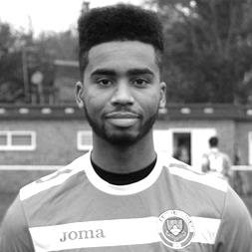
Club supported: Brentford

Favourite Food: Chicken

Favourite Film: Finding Nemo

Messi or Ronaldo: Messi

Favourite Drink: My protein – Cookies and Cream with Milk

Favourite Ground played at: The Valley, Charlton Athletic

Best moment for Epsom: My volley at Hanworth Villa last season

Previous Clubs: Colliers Wood United, Redhill

Matt’s Playing Stats: First Team Debut : 02/08/2014

Appearances: 34 - Sub: 4 - Total: 38 - Goals: 1

First Eleven Appearances - (max 19 – including Hartley Wintney – 17/11/15)
Name | Debut | 2014/15 |  |  |  | Career Totals
Name | Debut | App | Sub | Total | Goals | App | Sub | Total | Goals
AJAYI Tayo | 22/08/2015 | 0 | 2 | 2 | 0 | 0 | 2 | 2 | 0
COOPER-SMITH Daryl | 03/01/2015 | 12 | 4 | 16 | 5 | 21 | 7 | 28 | 11
CURRIE Sam | 04/08/2012 | 16 | 1 | 17 | 1 | 124 | 10 | 134 | 3
DAVISON Conor* | 22/08/2015 | 1 | 2 | 3 | 0 | 1 | 2 | 3 | 0
DEAN Dan | 02/08/2014 | 14 | 0 | 14 | 0 | 50 | 1 | 51 | 0
DEWAR Ali | 29/10/2011 | 0 | 0 | 0 | 0 | 55 | 35 | 90 | 10
EACOTT Michael | 02/08/2014 | 17 | 0 | 17 | 0 | 63 | 0 | 63 | 0
FARRELL Matt | 02/08/2014 | 18 | 0 | 18 | 4 | 59 | 3 | 62 | 11
FERDINANDO Matt | 20/09/2014 | 12 | 0 | 12 | 3 | 39 | 4 | 43 | 9
GRIFFIN Reisse | 08/08/2015 | 5 | 4 | 9 | 0 | 5 | 4 | 9 | 0
HASTINGS Craig | 08/08/2015 | 12 | 3 | 15 | 0 | 12 | 3 | 15 | 0
HENDRY Rob | 08/08/2015 | 17 | 1 | 18 | 5 | 17 | 1 | 18 | 5
HOUGH Kyle | 14/08/2007 | 15 | 1 | 16 | 12 | 311 | 16 | 327 | 183
JONES Adrian | 06/08/2011 | 1 | 0 | 1 | 0 | 21 | 0 | 21 | 0
KURDZIEL Jakub | 29/08/2015 | 1 | 0 | 1 | 0 | 1 | 0 | 1 | 0
MARVELL Dale* | 15/01/2000 | 8 | 4 | 12 | 1 | 269 | 49 | 318 | 86
MCGREGOR Alex | 08/08/2009 | 7 | 2 | 9 | 2 | 179 | 58 | 237 | 29
MCKAY Alex | 20/12/2008 | 12 | 1 | 13 | 0 | 97 | 27 | 124 | 8
NEALE Thomas | 13/10/2015 | 1 | 6 | 7 | 2 | 1 | 6 | 7 | 2
NEILL David* | 03/10/2015 | 1 | 1 | 2 | 0 | 1 | 1 | 2 | 0
NORTH Rhys | 16/08/2015 | 2 | 6 | 8 | 0 | 2 | 6 | 8 | 0
OLIVER Beckett | 29/08/2015 | 5 | 5 | 10 | 0 | 5 | 5 | 10 | 0
PANAYIOTOU Savvas* | 03/01/2015 | 2 | 0 | 2 | 0 | 18 | 3 | 21 | 3
SMITH Matt | 08/08/2009 | 0 | 0 | 0 | 0 | 91 | 43 | 134 | 10
TANTON Matt | 02/08/2014 | 16 | 0 | 16 | 0 | 34 | 4 | 38 | 1
TAYLOR James | 26/08/2013 | 14 | 2 | 16 | 0 | 70 | 10 | 80 | 3
Own Goal |  |  |  |  |  |  |  |  | 1
* Player has left the club

Match report by Sam Brooker
Epsom & Ewell 1-0 Chessington & Hook United
Combined Counties League – Premier Division - Saturday 7th November 2015

Salts snatch late win vs Chessington

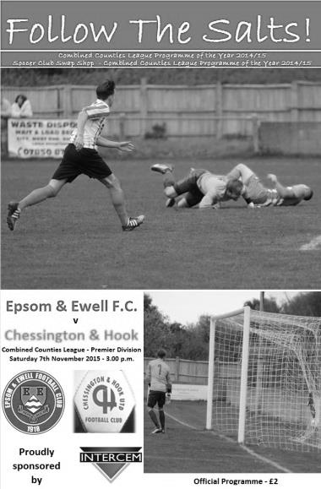
On Saturday Epsom and Ewell’s old foes were back - Chessington and Hook; a team that have defeated the Salts 1-0 in each of the last three home encounters. The home side, therefore felt they had something to prove going into this match, in addition to the opportunity of conquering 3rd place in the league. With regards to personnel, the outfit lacked Dan Dean (vice-captain) and the leading scorer, Kyle Hough, who picked up an injury as a result of his last contribution to the Epsom goal tally.

Both sides began tentatively in order to get used to the slippery surface, but also, because they were acutely aware that, in conditions where the ball was skidding on (and thus, through balls being difficult to track down), one goal could be the deciding factor.

The first controversy arose in the opening minutes when Daryl Cooper-Smith climbed high to compete for an aerial delivery with the opposition keeper Ian Hewitt, the latter went to ground following the collision and the ball spilled to Matt Farrell who buried the chance in the back of the net - but not before the young referee had blown his whistle for a foul and the goal was disallowed. However, it was a promising start from the home side.

The conditions definitely played their part in the match. Possession was extremely difficult to retain and as a consequence, the preferred offensive strategy was to send long, searching balls in towards the front men. It was in this way that Epsom came close to breaking the deadlock, a great ball was knocked in from the left wing and Rob Hendry’s glancing header forced a terrific reaction save, low to Hewitt’s left before it was cleared off of the line. Soon after, Matt Ferdinando whipped in a low cross that was miscued by the defender and Hewitt was called into action once again.

This spell of Epsom pressure continued with Farrell and Hendry executing some superb link up play between themselves that dissected the defence but, unfortunately, the onrushing Ferdinando sliced the shot well wide. Cooper-Smith was next to trouble

Hewitt, with a roaring right footed strike from outside of the box, luckily for Chessington, the shot was within reach of the goalkeeper’s palms. The away side occasionally found themselves in advanced and dangerous positions but were unable to capitalise, largely due to Michael Eacott’s overwhelming performance in the Epsom goal.

As both sides settled in to the half, goal scoring opportunities became scarce as a result of the excellent pressure that the teams exerted on each other, not allowing anyone enough time on the ball to cause any damage. However, our boys did dominate possession and this largely stemmed from our apparent aerial superiority (winning most of the battles in the air). Consequently, confidence grew and we began stringing some intricate passes together to cut through the crowd of yellow shirts. Matt Tanton was brought down late whilst on a direct run towards goal, Cooper-Smith fired the subsequent free kick goalwards but it clipped the wall and sailed over. Following this, Ferdinando sent in a series of fizzing corners which came to no avail as our attackers failed to make any significant contact - it was here that Hough’s goal scoring talent was most dearly missed. Credit must go to Chessington for smothering Epsom’s opportunities in the end but as the half drew to a 0-0 close, it was difficult to conclude that either side deserved to lead as both had squandered plenty of clear chances.

Epsom and Ewell made their intentions clear early on in the second half, with Farrell releasing a venomous shot that was dealt with by the outstretched arm of Hewitt. The Chessington framework was also rattled by a low Ferdinando drive along with their defence but overall, the half continued in a similar vein to the first, apart from a notable increase in physicality.

The home management attempted to impact the outcome of the match by bringing on Tom Neale in the place of Beckett Oliver in the 63rd minute - this substitution transpiring to be the difference between the two sides in the end. Hendry was also replaced by Reisse Griffin in the 75th minute.

The 46 in attendance were roused from their slumber in the 89th minute when Thomas Neale headed home six yards out from a superb Tanton cross. Putting the Salts 1-0 up with limited time remaining. The visitors had a case to be aggrieved as the goal resulted from a Chessington throw in that was awarded to Epsom. Nonetheless, it was an important win for Epsom that not only sends us up to third place, but also ends Chessington’s reign at our home ground.

Team: Michael Eacott, Sam Currie, Matt Tanton, James Taylor, Craig Hastings, Alex McKay, Beckett Oliver, Matt Farrell, Rob Hendry, Daryl Cooper-Smith, Matt Ferdinando

Subs: Tom Neale for Oliver (63), Reisse Griffin for Hendry (75)

Club Records - 21st November
Date | Day | Competition |  | Opponents |  | Scorers
21/11/25 | Sat | Surrey Senior League | A | Weybridge | 1-0 | T.Evans (pen)
21/11/31 | Sat | Amateur Cup 4q | A | Redhill | 2-1 | L.Graves, H.Payton
21/11/36 | Sat | Surrey Senior Cup 4q | H | Banstead Mental Hospital | 1-2+ | J.Jones (pen)
21/11/53 | Sat | Corinthian League | A | Edgware Town | 1-6 | B.Wiles
21/11/59 | Sat | Corinthian League | A | Dagenham | 0-2
21/11/64 | Sat | Athenian League 1 | H | Horsham | 5-6 | T.McGrogan, J.Eales, B.Mackay (3)
21/11/70 | Sat | Athenian League 2 | A | Rainham Town | 2-2 | K.Spears (2)
21/11/80 | Fri | Isthmian League 1 | H | Lewes | 2-0 | T.Tuite (2)
21/11/81 | Sat | Isthmian League 1 | A | Aveley | 0-1
21/11/87 | Sat | Isthmian League 2s | H | Petersfield United | 5-1 | A.Flaherty (2), J.Richardson (2), N.Robson
21/11/92 | Sat | Isthmian League 3 | A | Aldershot Town | 1-1 | A.Nimmo
21/11/95 | Tue | Surrey Senior Cup 4q | A | Carshalton F.C. | 3-0 | S.Smith (3)
21/11/98 | Sat | Isthmian League 3 | A | Tilbury | 1-2 | C.Desbrow
21/11/06 | Tue | Combined Counties  Premier Division | H | North Greenford United | 0-0
Historical Decades
Date | Day | Competition |  | Opponents |  | Scorers
90 years ago – Epsom Town F.C.
21/11/25 | Sat | Surrey Senior League | A | Weybridge | 1-0 | T.Evans (pen)
80 years ago – Epsom F.C.
23/11/35 | Sat | London League | A | Bostall Heath | 3-4 | H.Pullen (2), J.Jones
70 years ago – Epsom F.C.
17/11/45 | Sat | Surrey Senior Cup 1 | H | Carshalton Athletic | 7-3 | G.Brogdale (4), S.Tingey, R.Buller, R.Crowther
60 years ago – Epsom F.C.
19/11/55 | Sat | Corinthian League | A | Tilbury | 0-2
50 years ago – Epsom & Ewell F.C.
27/11/65 | Sat | Amateur Cup 4q | H | Leyton | 1-4 | K.Welham
40 years ago – Epsom & Ewell F.C.
22/11/75 | Sat | Athenian League 2 | H | Windsor & Eton | 5-2 | T.Tuite (2, 1 pen), A.Reid, B.Denman, T.Coombe
30 years ago – Epsom & Ewell F.C.
23/11/85 | Sat | Isthmian League Premier Division | H | Yeovil Town | 2-2 | P.Kemp, D.Taylor
20 years ago – Epsom & Ewell F.C.
21/11/95 | Tue | Surrey Senior Cup 4q | A | Carshalton F.C. | 3-0 | S.Smith (3)
10 years ago – Epsom & Ewell F.C.
19/11/05 | Sat | Isthmian League 2 | H | Hertford Town | 0-2

History Corner – 21st November
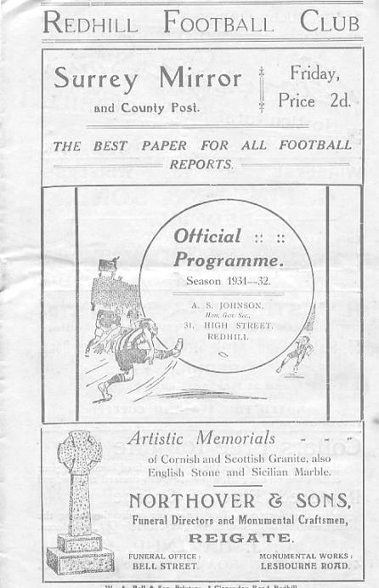
84 years ago today we beat Redhill 2-1 in the Amateur Cup at the Memorial Ground with goals from Leslie Graves and Harry Payton. At least 3,500 spectators were present, (the Epsom Herald said 4,000) including 1,000 from Epsom to see us lead through Graves in the first half, and although the Lobsters equalised with a penalty after 65 minutes, Payton’s winner two minutes later capped a fine team display. (see programme right). This win earned us a trip to Ipswich Town in the First Round (last 64).

79 years ago today we were edged out of the Surrey Senior Cup 2-1 after extra time by Banstead Mental Hospital. We had beaten them 6-0 in an Amateur Cup tie earlier in the season, but missed chances cost us our only chance to play against tenants Ewell & Stoneleigh in the next round. The Hospital side actually went all the way to the Semi-Final, narrowly losing to Kingstonian at Plough Lane, Wimbledon F.C.

70 years ago this week Gordon Brogdale scored four goals for the second straight week as Carshalton Athletic were crushed 7-3 at West Street in the Surrey Senior Cup. Corinthian Casuals would then defeat us 6-0 in the Quarter-Final at Richmond Road, Kingston.

51 years ago today spectators witnessed the biggest collapse in club history as we led Horsham 4-1 at half time, extending this to 5-1 early in the second half, yet somehow contrived to lose 6-5 to Horsham at West Street. Bill Mackay scored a hat trick, whilst young striker Johnny Eales scored his first ever goal for our club, but still it was not enough!

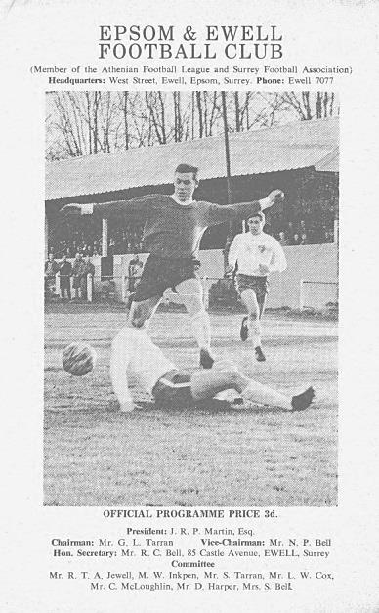
50 years ago this week a Keith Welham goal was not enough as we were defeated 4-1 by Leyton in the Amateur Cup. It was the last time that we would ever reach the final qualifying round and this match is immortalised in the programme cover picture of Brian Coombes that we used from 1967-70. (see programme left).
30 years ago this week we hosted the mighty Yeovil Town in an Isthmian Premier League match. This was the first time we were ever placed on the football pools coupon and rumour has it that Dave Taylor’s late equaliser in our 2-2 draw earned someone a jackpot! Dave is the father of current defender James and is regularly at our matches. In the opposition side were famous faces like Gerry Gow, and a future star who scored their opener at West Street, John McGinlay.

20 years ago today Steve Smith scored his one hat trick for the club as we defeated Carshalton F.C. the Amateur side by three clear goals in the Surrey Senior Cup at Merland Rise.

From behind the goal
Knaphill 1-1 Epsom & Ewell
Combined Counties League Premier Division - Saturday 14th November 2015

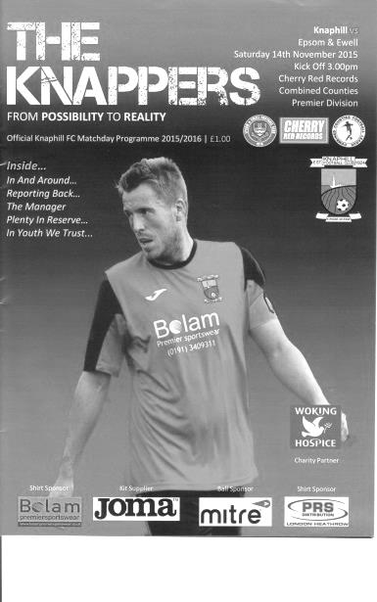
Unfortunate Salts learn lesson the hard way

We continued our recent run of fixtures against the better sides with a trip to Knaphill's pleasant Redding Way ground, hoping to continue the good results. Unfortunately, and despite being totally in control of this match for 75 minutes of the game, a sloppy fifteen minute period midway through the second half enabled the home side to salvage a point that they didn't really deserve.

For the first time this season, Glyn named an unchanged starting eleven, following our win over Chessington & Hook on Saturday. This was both good and bad news. You always like to see a consistent line-up when possible, but it also meant that we continued to miss the contributions of the injured Dan Dean and Kyle Hough, although our leading striker was at least able to take the field for an eight minute cameo and almost won the match for us.

Despite the lack of changes to the personnel, the improvement in performance this week on last was almost impossible to compare. Faced with a lush green pitch, albeit a little squelchy in parts due to a pre-match downpour, our players would have been delighted, and we came out of the blocks in top gear, clearly intent on maintaining our perfect record at Knaphill. Early pressure forced the home side onto the back foot and Matt Ferdinando and Matt Farrell were both prominent in the early stages; the former shooting over after one of his trademark mazy runs, while Beckett Oliver cut in from the left, and a nice move also involving Rob Hendry and Daryl Cooper-Smith set up Farrell, but his shot was at a comfortable height for the excellent Richard Shelley in goal and he made a good, if fairly comfortable save from close range.

We continued to press and broke through in the 12th minute. A lofted ball over the very high line of defence was headed towards Shelley by the stretching defender, but Cooper-Smith got there ahead of him and as he collided with the keeper, his contact on the ball was enough to see the ball run towards the goal from the edge of the area, just dribbling over the line before our man was able to make sure by then smashing the ball into the net for good measure!

Does this sound familiar? We scored a goal in almost identical circumstances just two weeks previously when Hough scored at Ashford and regrettably this goal contained a similar sting in the tail as Cooper-Smith had to leave the pitch shortly afterwards having received a stud to his shin during the collision. His shin pad afterwards looked as though someone had shot it with an air pistol! Tom Neale replaced him, as he had done with Hough at Ashford and had another promising performance.

His first chance came a few minutes later when Farrell set him up but he delayed his shot at first before firing high and wide. In fact, this became the story of the first half with the words of the supporting Knaphill boys team behind me ringing in my ears "how wide do you want the goal"! It

was hard to argue with them, although at least it was positive that all the attacks were coming from us.

Michael Eacott had to make a hurried clearance and Oliver made a good defensive block at the far post after a low ball had whizzed across our area but otherwise the possession in the first half an hour was all Epsom's.

In the 28th minute came a moment of controversy when Neale broke through on the right. He rode one challenge before being cynically dispatched by Jamie Doble the Knaphill Captain. He received a yellow card for the challenge, which was probably correct as another defender was in the vicinity and might have been able to get over, but it occurred to me later that bearing in mind the type of challenge, he could and maybe should have been sent off for violent conduct. Either way, it didn’t happen and our free kick came to nothing.

Craig Hastings was just off target with a shot after Alex McKay had headed a deep Ferdinando corner back to him, and the half ended with Eacott having to make his first save of the match, low to his left and the subsequent home corner was cleared.

We started off well again in the second half and it seemed like just a matter of time before we would get a second goal. Hendry struck well but straight at the keeper from twenty yards and soon after Neale found his effort deflected wide by Shelley after Ferdinando had put him clean through on goal. Moments later Hendry set up Farrell whose shot hit the outside of the post from eight yards. Either relieved or encouraged that they were still in the game and with memories recent of their recent comeback in a Vase tie against Cray Valley, the home side started to contest things in the middle of the park for the first time and we weren't able to exert the same control for a while.

Eacott palmed away a deep cross with the subsequent incoming shot being deflected into the side netting, but from the corner our keeper missed his clearance and it got a bit messy in front of goal with a hacked clearance and then a combined three man block of another low shot as our opponents had their best spell of the match. We had lost momentum and despite a low strike from Ferdinando, again well saved at the near post, we were second best and a low ball into the right hand channel was hooked across into the far corner of our goal from just inside the penalty area by Jack Mazzone in the 77th minute. It was a really good strike and Eacott had no chance with it. Enter Hough to join the recently introduced Reisse Griffin and we belatedly took over proceedings again as the game reached its final stages.

We had one scare when Eacott had to be alert to tip a free kick over that had bounced and skidded in front of him, but we were chasing the points now with an urgency that had just left us for that fatal quarter of an hour. And we so nearly got a late winner too after Hough had made space and saw his low drive was blocked on the line by a defender with Neale knocking in the loose ball from close range only to be ruled offside. There was a defender on the line, but unfortunately the keeper was further upfield, so from where I was it looked the right decision, even if it came a little late. We also had a shout for a penalty in injury time when Ferdinando's low shot was spilled and may have been impeded as he went in for the loose ball, only to find the referee giving the free kick the other way. It was a frustrating way to end the match, but even more so when you look back on how well we had played, only to be punished for a slack fifteen minutes. It is a lesson that we need to learn quickly with a trip to leaders Hartley Wintney coming up in just three days.

Team: Michael Eacott, Sam Currie, Matt Tanton, James Taylor, Craig Hastings, Alex McKay, Beckett Oliver, Matt Farrell, Rob Hendry, Daryl Cooper-Smith, Matt Ferdinando

Subs: Tom Neale for Cooper-Smith (16), Reisse Griffin for Oliver (66), Kyle Hough for Hendry (83)

Centre page for results

Centre page for results



From behind the goal
Hartley Wintney 3-3 Epsom & Ewell
Combined Counties League Premier Division - Tuesday 17th November 2015

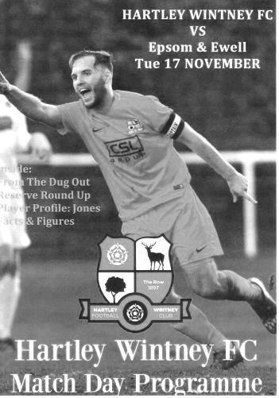
Salts fight back against the leaders and the elements to claim a draw

Despite the newly named storm Barney and the longest trip of the season to face the runaway leaders of the division, we dealt with almost everything that was thrown at us, and became the only team aside from Step Two Eastbourne Borough to score three times against them. In fact, had it not been for some superb goalkeeping from the home custodian Craig Atkinson in the first half, we might well have been celebrating a famous victory.

We were unchanged from our draw at Knaphill, with exception of Kyle Hough returning to the starting eleven. Rob Hendry moved to the left flank with Beckett Oliver reverting to the bench. The pitch was understandably heavy but a vast improvement on the sandy morass we had encountered a couple of seasons previously and both teams tried to play as much football as they could, probably well aware that attack was the best form of defence in these blustery conditions. We've played in windier conditions before, Moneyfields in the Vase springs to mind as do a couple of wintry outings at Merland Rise, but not too often.

The wind favoured us in the first half. Although not quite end to end, it certainly went more in our direction than theirs. As a result it was disappointing to go behind after 16 minutes when a near post corner wasn't attacked by our players and Liam Eagle nipped in to clip the ball past Michael Eacott at his near post. In fifteen league matches so far, this was only the fourth goal we have conceded in the opening half, but we responded really well to the setback.

After 20 minutes Daryl Cooper-Smith was put through on the left and he rounded the keeper with ease. As he cut in from the edge of the box he lashed a shot goalwards that hit defender Liam Eagle on the side of the head and away for a corner. Although the set piece came to nothing we pushed again and Atkinson made a hurried clearance as he came out to clear the danger. The ball went to Matt Ferdinando, who saw the keeper was off his line and shot perfectly from between 40-45 yards. Those of us who were behind the goal instantly knew it was going in for a spectacular equaliser as the retreating Atkinson couldn't get back in time, ending up in the back of the net with the ball. 22 minutes gone and this already looked like it was going to be a great game.

We were confident now and Sam Currie made a great overlap on the right; his cross being flicked on by a Hartley defender but only as far as Rob Hendry who retrieved the ball and unleashed a swerving low shot that was flying into the bottom corner until Atkinson made a great block at full stretch. The ball could have gone anywhere from the parry, but sometimes the keeper deserves a bit of fortune as it was a great save. He wasn't finished yet as a minute later Ferdinando beat his man as the ball bounced awkwardly and then hit a scorching low drive. Not only was the shot saved, the ball was held so there was no chance for our incoming strikers to take advantage, which they surely would have.

The home side had a shout for a penalty on the half hour mark when a right wing cross was met with a shot that ballooned over the bar from about 15 yards out although that player was on the

ground in a heap with one of defenders shortly after this. I didn't get a good view and maybe the referee didn't either and a goal kick was awarded.

Hendry then had a good chance on the left, but with the keeper exposed and Hough and others behind him waiting in the area, he took a touch to go around the keeper and ran the ball out of play. After 42 minutes we crafted a great move when Ferdinando broke on the right and crossed deep where Hough produced a great header down to Cooper-Smith who lashed the ball goalwards from just eight yards and with the wind behind it, but Atkinson made as good a save as I've seen in years to keep the ball out. In fact we nearly conceded on the counter attack but the left wing cross had just too much on it for the incoming striker who couldn't keep his shot on target.

As the half time whistle blew there was a concern that we hadn't been leading by that point and I thought that we would be defending for large parts of the second half as the home side would have the wind, but as we came out for the second half, it appeared that the wind had shifted and was arguably more side to side for this period. We started where we left off with Cooper-Smith firing just wide from 20 yards.

Unfortunately a harshly awarded free kick against Craig Hastings in the middle of our half turned into something more serious as the delivery in led to a collision between Alex McKay and their striker. Despite the ball being too far ahead for either of them to reach, the referee decided McKay had fouled his man and booked him after awarding the penalty. This was then tucked away by former Salt Joe Paris, although Eacott guessed the right way and was unfortunate not to stop it. That goal came in the 57th minute and worse was to come just three minutes later as their tricky left winger fired in a dangerous cross to the near post where Hastings got there first but could only divert the ball just inside the near post to give the hosts a 3-1 lead.

We could have easily gone into our shell at this point and given up the ghost to find ourselves seemingly in an impossible position after playing so well, but it says a lot for the strength of character of our side that we kept going. Hough was replaced by Tom Neale after an hour and his first chance turned the game as he broke through on goal, only to be cynically tripped by the covering Eagle. At Hartley, you cannot stand behind one of the goals, so from the side of the pitch I had a clear view that our man was through and would not have been caught by any other defenders but the referee decided to only produce the yellow card. Any frustration at this was forgotten immediately as Ferdinando's 64th minute free kick went straight through the wall and into the net with Atkinson unsighted.

As we pushed for an equaliser we left some gaps and a missed far post header from the home side was probably the most dangerous of them. McKay limped off shortly after this and was replaced by Reisse Griffin. Whilst this meant that we missed Ferdinando's trickery on the wing, as he went more central, Griffin continued to threaten and from one of his passes the ball was spread over to Hendry on the left who again found his strike parried away for a corner. After 87 minutes we got what we deserved as another corner wasn't cleared before Neale forced the ball in off the far post from close range. There was a big shout for handball in the build up from the home players, but maybe that evened up the free kick that led to the penalty at the other end.

The whistle blew soon after and although a draw is rarely a good result, I think both teams would have taken a point before the match and although we had more dangerous chances in the game, possession was even and a draw was ultimately a fair result. Because of the circumstances, it probably felt like a win to most Epsom supporters and Neale is also developing a habit of scoring late important goals. Long may this continue!

Team: Michael Eacott, Sam Currie, Matt Tanton, James Taylor, Craig Hastings, Alex McKay, Rob Hendry, Matt Farrell, Kyle Hough, Daryl Cooper-Smith, Matt Ferdinando

Subs: Tom Neale for Hough (63), Reisse Griffin for McKay (70)

EL Records Premier Challenge Cup
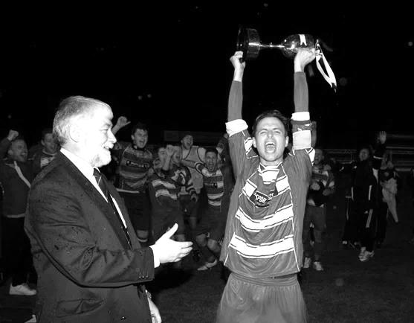
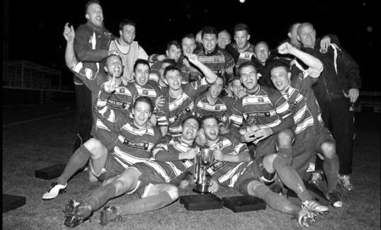
Second Round
Dorking Wanderers | 2-1 | South Park Reserves
Westfield | 1-0 | CB Hounslow United
Bedfont & Feltham | 1-5 | Colliers Wood United
Dorking | 0-3 | Knaphill
Badshot Lea | 2-4 | Spelthorne Sports
Hanworth Villa | 1-2+ | Chertsey Town
Ashford Town (Mx) | 2-1 | Epsom Athletic
Hartley Wintney | 4-2 | Horley Town
Banstead Athletic | 1-1+ | Epsom & Ewell
Epsom & Ewell won 7-6 on penalties
Sheerwater | 3-3+ | Frimley Green
Frimley Green won 8-7 on penalties
Farnham Town | 3-2 | Abbey Rangers
Camberley Town | 4-2 | Eversley & California
AFC Hayes | 0-1 | Banstead Athletic
Redhill | 3-0 | Sutton Common Rovers
Worcester Park | 1-5 | Chessington & Hook United
Cove | 1-6 | Cobham
Third Round
Camberley Town | 15/12 | Spelthorne Sports
Cobham | 15/12 | Frimley Green
Redhill | 15/12 | Farnham Town
Raynes Park Vale | 15/12 | Westfield
Epsom & Ewell | 12/1 | Ashford Town (Mx)
Colliers Wood United | 16/12 | Dorking Wanderers Reserves
Knaphill | 15/12 | Chertsey Town
Hartley Wintney | 15/12 | Chessington & Hook United

Hanworth Villa F.C. – History
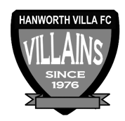
Hanworth Villa were formed in 1976 following a managerial disagreement at another long established Hanworth club. In the early years the team struggled in Division One of the Hounslow & District League, scoring a goal was usually celebrated with a public holiday. During the close season and following hard work by Jimmy Connors, who rebuilt the team, they finished Division One Champions.

The following season saw the club start an incredible run in the league, which finished 68 matches later, with 'The Villains' winning the Hounslow Premier League, and the West Middlesex Division One and Two Championships. The success continued with Hanworth being elected to the newly formed Middlesex County Football League.

From 1980 the club had a nomadic existence but in 1997 moved to its existing Headquarters at Rectory Meadow. This move led to the formation of Hanworth Villa Sunday, and later a reserve team, being an amalgamation of teams from - The Sawyers Arms, The Queen Dowager, and Feltham Railway Club, not that the lads like the odd beer! A Chiswick League double in 1993 and a 19-0 Cup Final victory in the National Railways Cup (did the opposition run out of steam?) cemented the successful amalgamation.

Following hard work by Dave Brown the club was granted a lease at Rectory Meadow. At last we had a permanent home and could set about converting an existing pavilion into a clubhouse, which has become known locally as “The Ranch”. With a permanent base we were able to concentrate on improving our football, and recent years have seen all our teams win numerous trophies, the most notable performance being by our Sat 1st team who landed “the treble” in 02/03, winning the Middlesex County Premier league, the Open Cup and the League Cup. After another premier league title in 2004/05, this time with a record number of points, it was decided that it was time to move on and the club were elected to Division One of the Combined Counties League in time for the start of the 05/06 campaign.

The Combined Counties Experience
It took a while to adapt to the new level of football, but in our second season we managed to win the Challenge cup. The following season, 2007/08, we successfully managed to defend the Challenge Cup and narrowly missed out on the league title, finishing a creditable second; our facilities however, prevented our promotion into the Premier Division. The club were determined to ensure that that situation wouldn’t arise again, and, with typical determination, the committee managed to raise the funds to ensure that floodlights and a spectator stand were installed in time for the start of the 08/09 campaign. The effort wasn’t in vain as we once again finished second in what was a very tight end to the season with the top 5 sides being separated by just 3 points. After a successful ground inspection we were promoted to the CCFL Premier in time for the 2009/10 season.

Our debut season in the Premier proved to be as difficult as we expected. Points were few and far between for the first half of the season, but we gradually started to come to terms with the improvement in standard required, and we managed to put together performances worthy of a CCFL Premier side. By the end of the season we had obtained enough points to finish in 17th position, 3 clear of the relegation places.

That 1st season taught us a lot and changes put in place during the close season allowed us to have a more comfortable second season, in which, we not only finished a creditable 5th in the league, but also reached the finals of the Middlesex Senior Charity Cup and also, for the 2nd consecutive season, the Southern Combination Cup. Unfortunately we lost out by the odd goal in both finals.

2012/13 saw us finish 3rd in the CC FL our highest ever position in the football pyramid since we were formed in 1976. There was also a very creditable run in both the FA Cup and Vas competitions. In the FA Cup we just lost out to AFC Totton 3-2 missing our on a first round proper tie with Bradford Park Avenue. Our run in the FA Cup saw wins over Shrivenham, Bedfont Sports, Wembley, Aveley and Slough Town. In the FA Vase we lost out to Herne Bay one of the beaten semi-finalists at the third round stage.

The 2013/14 season contained a top ten finish and another good F.A. Vase run although last season was a battle throughout, only surviving at the end after a good end of season run.

Every Opponent A-Z
Over the years we have played many, many different opponents. Exactly how many is a difficult question, as it all depends on your definition. Are Camberley & Yorktown different to Camberley Town, or are Epsom Town different to Epsom F.C. or Epsom & Ewell F.C.?

In my analysis I have classed them as the same team, and will work through them all from A to Z. Some we have played many times, whilst others we have met just once or twice. Enjoy!


Raynes Park Vale / Malden Vale: Played 24 - W11 D5 L8 - F51 A35 - PPG - 1.58 - Above Average

Grand Drive is not an inspiring venue. Unkempt and in various states of disrepair it resembles a building site at times. My first visit was for a friendly back in 1986 but we have made eleven competitive visits since. In addition, it became the home ground for our Reserves and Youth teams upon our departure from Banstead Athletic for a couple of seasons from 2010.

The early story of Malden Vale takes them back to a foundation date of 1967. The club with whom they merged in 1994, Raynes Park, had actually been created from an offshoot of the Southern Railway team that had actually contested matches against us back in the early twenties, originally as Brighton Railway before changing their name in line with the company and spending two seasons from 1923/24 as members of the Surrey Senior League. The second and last season at that level was the first time we had met the club at Senior status and they were actually playing home games at The Nest, the recently vacated Crystal Palace and former Croydon Common (pre WW1) home ground, before facing almost seventy years of relative obscurity prior to their merger.

Before the clubs joined we first played Malden Vale in a County Cup tie in January 1989, winning 2-0 in a match containing a great comedy own goal where the defender tapped the ball wide of his keeper under pressure for our second and clinching goal. I had a great view of it behind the goal!

They joined the Isthmian League from the Combined Counties League the following season and although we lost 1-0 at home, by the time of the return under the renewed Management of Adrian Hill, we were inspired, winning 5-0 on our first ever competitive visit to Grand Drive.

The following season we lost both matches and at the end of the season, Division Two North and South were converted into Divisions Two and Three with us in the lower half and Vale in the upper half. As a result we only met once more in the next twelve years; a Surrey Senior Cup tie on 27th September 2000, by which time they had resigned from the Isthmian League and merged into the side we now recognise.

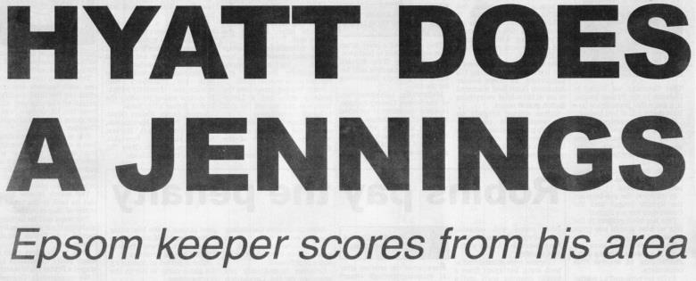
This match would be remembered for a very rare event, as Dave Hyatt our keeper scored with a goal kick after 71 minutes on our way to a 3-1 win. Dave joked afterwards that he had spotted the keeper off his line from 100 yards. The keeper in question was Gary

Brigden, now one of the main officials at Sutton Common Rovers and yes, he does remember it!

In 2006 we met again as members of the Combined Counties League ourselves, and our first meeting was a cracker as we trailed, then led, only to be level at half time. Dale Marvell completed his hat trick after we had trailed again and Russell Newbury scored a header in injury time on his only appearance for the club to win it. Or so we thought! We were unable to defend for the remaining minute of the game and they forced an equaliser in a 4-4 draw. This remains to this day the last time that an Epsom player has scored a hat trick but not finished on the winning side!

We won 2-1 there in the final match of the season, by now under the Management of Lyndon Buckwell, and decent results followed, with two wins and two draws in our next four league matches; the highlight of which was a 5-3 win at Grand Drive in a match where we totally dominated and they scored with their three shots at goal.

Maybe since then we have taken them a little for granted and this cost us frequently, winning only one of our next six matches and suffering a league double in 2011/12.

Since our move to Chipstead results have been better. We defeated them 6-1 on 15th December 2012 at High Road during our club record 12 League match winning run. The twelfth of these was the return match at Grand Drive, where we had lead 2-0 but the home side reduced the arrears and when Carl Downs then conceded a penalty and was sent off, there seemed no way we could score a winner to keep the run going. However, Robbie Burns had other ideas and retrieving a deep corner, he beat two men before firing into the top corner in the 88th minute, quite possibly his most memorable and spectacular goal for our club, and there are quite a few to choose from!

We drew one and won one in 2013/14, being held back by a 91st minute equaliser in a 2-2 draw at High Road, and in 2014/15 we lost to a deflected goal in our first home match of the season before restoring order with our third straight win at Grand Drive by two goals to nil; a match where we were also denied a third goal by the Assistant spotting a non-existent handball by Kyle Hough.

We of course, continue as league rivals to this day and won 3-1 earlier in the season at High Road. They regularly punch above their weight and although not a particularly fashionable club at a venue where many postponements occur, they battle on regardless and although the future at a ground owned by the MK Dons owner is uncertain, they remain thoroughly deserving of their place at this level, even if maybe their ground no longer does.
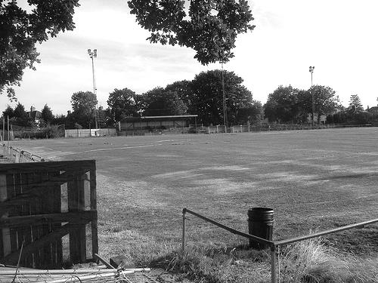

Player Sponsorship
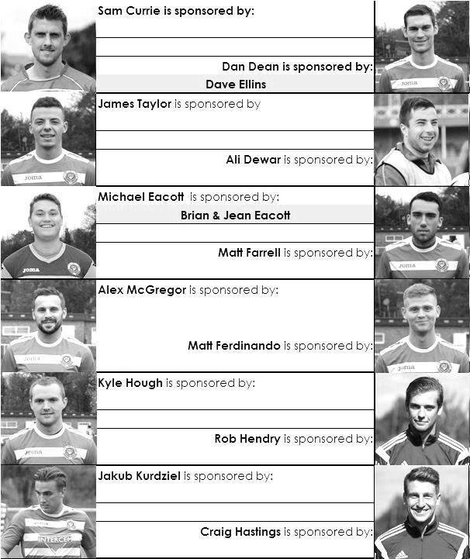

Here is the current list for the 2015/16 season showing all of our players and Management that are currently available for sponsorship this season.

Sponsorship costs just £40 and it is easy to do. Just select a player who has not been previously sponsored and let a Committee Member know that you would like to sponsor them. Beware though. Until we have received the money it is possible for someone to jump in front of you, so don’t delay, sponsor today!

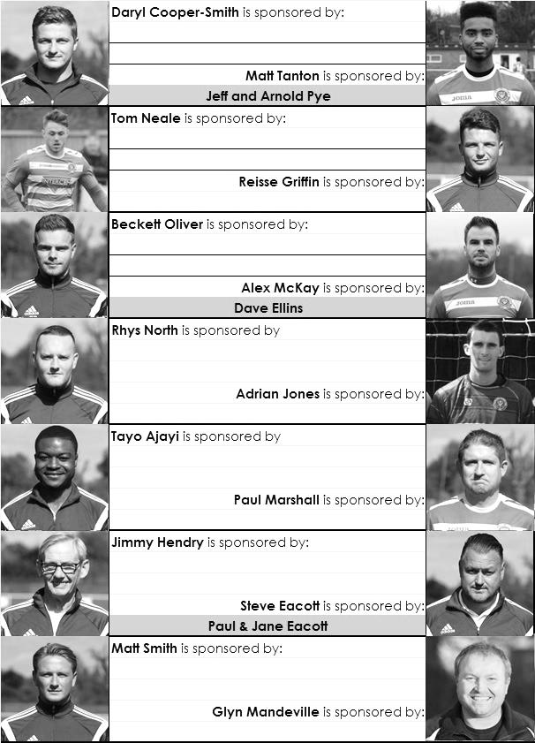

Match and Ball Sponsorships – 2015/16
Opponent | Date | Match and Match Ball Sponsor
Hoddesdon Town | 18/07/15 | Geoff Dyke
Windsor | 08/08/15 | Club President Stella Lamont
Erith & Belvedere (FAC) | 16/08/15 | Mike Lovett
Raynes Park Vale | 31/08/15 | EEFC Management Committee
Colliers Wood United | 08/09/15 | Bookham Building Shop – www.buildingshop.co.uk
AFC Hayes | 19/09/15 | John Bonner
Farnham Town | 26/09/15 | Ezara and Inaya Beddoe – our youngest supporters!
Chertsey Town | 17/10/15 | Club Media Officer – Richard Lambert
Dorking Wanderers (SSC) | 20/10/15 | Tony Ferdinando
Chessington & Hook United | 07/11/15 | Paul Merritt
Hanworth Villa | 21/11/15 | Maggie Beddoe
Guildford City | 05/12/15
Cove | 08/12/15
Sutton Common Rovers | 19/12/15
Redhill | 02/01/16
Ashford Town (Mx) (LC) | 12/01/16
Spelthorne Sports | 16/01/16
Hartley Wintney | 30/01/16
Bedfont Sports | 13/02/16
Horley Town | 27/02/16
Knaphill | 12/03/16
Westfield | 26/03/16
Badshot Lea | 09/04/16
Camberley Town | 16/04/16
Ashford Town (Mx) | 30/04/16
For League, League Cup and Surrey Senior Cup Matches:
Match sponsorship - £40.00 Match ball sponsorship - £25.00. Combined £55.00.
For F.A. Cup and F.A. Vase matches:
Match sponsorship - £50.00 Match ball sponsorship - £30.00. Combined £65.00.

Sponsorship includes: (x2 for match, x3 for match and ball)

Admission, programmes, hospitality and advertising and mascot for the day (if required).
If you are interested, just speak to a Committee Member, or drop me an email at: richard.c.lambert@gmail.com


We also thank our Kit Sponsors INTERCEM

Salts Super Six Predictor
The Salts Super Six Predictor Competition is live again and the tickets are on sale at today’s game to the left of the gate. We had our second winner last time out when Maggie Beddoe selected all six results correctly.

The competition is easy to play! To win, you simply need to predict the results of the six matches correctly from the three options, fill in the form and make sure it is back with our sellers before the deadline on the ticket.

If you are a club regular, you just need to place your name on the sheet, although if you aren’t, then we’ll need a contact number from you too. We will announce any winners on the website within three working days, so don’t worry we won’t miss you!

The jackpot is now reset to £50 but it won’t take long before it will start rising again!

Please note that if there is more than one winner, the prize pot would be shared between the winners. All you need to do now is have a go, as many times as you like!

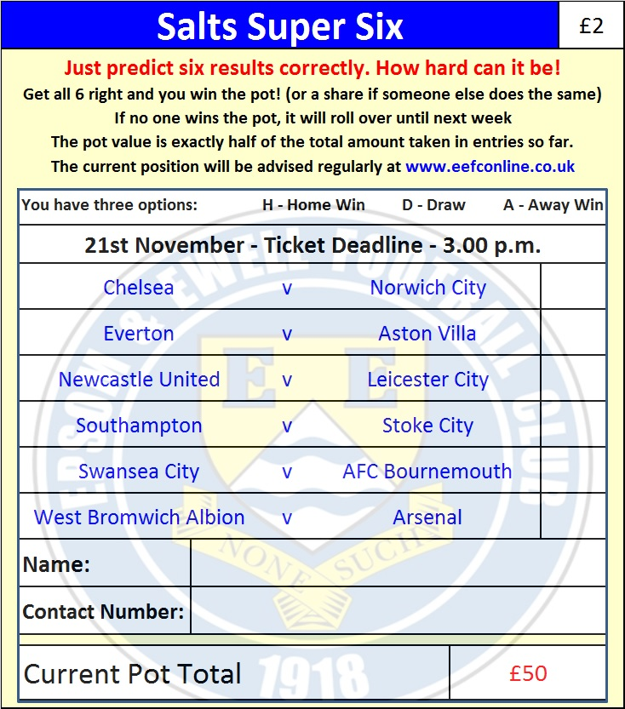

Good luck!

Combined Counties League – Premier Division
Saturday, 21st November 2015 - Kick-off 3.00 p.m.
Epsom and Ewell  (Royal Blue & White hoops) | V |  | Hanworth Villa  (Red and White)
Squad | NUMBERS
Michael Eacott |  |  | Terry Buss
© Sam Currie |  |  | Tom Martin
Matt Tanton |  |  | Adam Baigent
Craig Hastings |  |  | Tom Dilloway
James Taylor |  |  | Jamie Miles
Dan Dean |  |  | Lee Morley
Alex McKay |  |  | Junior Wright
Matt Farrell |  |  | Jack Buckle
Kyle Hough |  |  | Steven Loveridge
Rob Hendry |  |  | Jimmy Major
Matt Ferdinando |  |  | Luke Muldowney
Daryl Cooper-Smith |  |  | Ade Oshilaja
Beckett Oliver |  |  | Adam Willis
Tom Neale |  |  | Joe Johnson
Dale Marvell |  |  | Ross Cheetham
Alex McGregor |  |  | Matt Grave
Reisse Griffin |  |  | Jesse Atiase
Rhys North |  |  | Billy O’Malley
Steve Rowe |  |  | Harry Cushen
Tayo Ajayi |  |  | Dale Marvell
Jakub Kurdziel
Glyn Mandeville | MANAGER |  | Matt Grave / Luke Muldowney / Adam Willis
Matt Smith | ASSISTANT |  | Matt Grave / Luke Muldowney / Adam Willis
Steve Eacott / Alex McKay / Jimmy Hendry | COACHES / PHYSIO
REFEREE: P.Jones (Ewell)
ASSISTANTS: W.Ingram (New Malden), G.Smith (Farnborough)
Today’s Match and Match Ball are sponsored by
Our recent Salts Super Six winner, Maggie Beddoe

OUR NEXT VISITORS TO HIGH ROAD
Guildford City
Saturday 5th December 2015 - Kick-off 3.00 p.m.
Combined Counties League – Premier Division

